

**VCE General Mathematics Units 1&2**

**AT 1.3– OUTCOMES 1, 2 & 3**

**Week 11 Term 1 2023**

**You will have 75 minutes to complete this SAC.**

**Calculators and notes are permitted.**

**Linear Relations and Equations Test**

Name: ____________________________________________

Circle teacher’s name: Ms Jabeen Ms Le Mr Rossignolo Ms Yang

***Note:*** *The grade or score for this task is only part of the internal assessment for this Unit. Your* ***total*** *School-assessed Coursework score may change as a result of statistical moderation.*

**Total : ____________ /60**

**Satisfactory Completion? S/N: ______**

--------------------------------------------------------------------------------------------------

**Assessment Criteria**

Students should be able to:

* Define and explain key concepts and apply a range of related mathematical routines and procedures.
* Apply mathematical facts, concepts, models and techniques to investigate and analyse expended application problems in a range of contexts
* Use numerical, graphical and symbolic functionalities of technology to develop mathematical ideas, produce results and carry out analysis in situations requiring problem-solving, modelling or investigative techniques or approaches.

|  |
| --- |
| **Instructions**  A single bound reference and a CAS and scientific calculator permitted.  Answer all questions in the spaces provided.  Round final solutions to 2 decimal places unless specified otherwise.  In questions where more than one mark is available, appropriate working must be shown.  Multiple choice questions are worth one mark each. |

|  |  |  |
| --- | --- | --- |
| **Section A** | **Multiple Choice Questions** | **14 marks** |

*Circle the letter corresponding to the correct response.*

|  |
| --- |
| **1.** If $s-10=54$, what is the value of ? |

|  |  |
| --- | --- |
| **A.** | $$4$$ |
| **B.** | $$5.4$$ |
| **C.** | $$44$$ |
| **D.** | 64 |
| **E.** | 540 |

|  |
| --- |
| **2.** What is the value of $I$, when $P=2000$, $R=0.04$ and $T=3$ are substituted into the rule ? |

|  |  |
| --- | --- |
| **A.** | 2003.04 |
| **B.** | 2003.4 |
| **C.** | 24000 |
| **D.** | 2400 |
| **E.** | 240 |

|  |
| --- |
| **3.** Which of these equations has the solution ? |

|  |  |
| --- | --- |
| **A.** | $$5+a=–7$$ |
| **B.** | $$12- a=14$$ |
| **C.** | $$a+8=10$$ |
| **D.** | $$7a=14$$ |
| **E.** |  |

|  |
| --- |
| **4.** The cost of hiring a plumber is $150 plus $85 for every hour of work. If a plumber works for 3.5 hours on a particular job, how much will he earn? |
| |  |  |  | | --- | --- | --- | | **A.** |  |  | | **B.** | $405 | | **C.** |  | | **D.** |  | | **E.** | $610 | |

|  |
| --- |
| **5.** Which is correct if $y$ is made the subject of the equation ? |
| |  |  |  | | --- | --- | --- | | **A.** |  |  | | **B.** |  | | **C.** |  | | **D.** |  | | **E.** |  | |

|  |
| --- |
| **6.** The solution to the simultaneous equations $$3y-2x=8 \\ 2y+5x=-1$$ Is: |
| |  |  |  | | --- | --- | --- | | **A.** |  |  | | **B.** |  | | **C.** |  | | **D.** |  | | **E.** | $$x=1, y=9$$ | |
| **7.** The slope of the line passing through (10, 9) and (6, -3) is: |
| |  |  |  | | --- | --- | --- | | **A.** | -3 |  | | **B.** |  | | **C.** |  | | **D.** | 1.5 | | **E.** | 3 | |

|  |
| --- |
| **8.** Players at a football club pay a fee of $130 each year. They also pay a fee of $12 for every game they play in that year. Last year, Maddie paid a total of $262 in fees at this football club. How many games did Maddie play last year? |
| |  |  |  | | --- | --- | --- | | **A.** | 10 |  | | **B.** | 11 | | **C.** | 12 | | **D.** | 13 | | **E.** | 14 | |

|  |
| --- |
| **9.** An equilateral triangle has side lengths that are $x$ cm long. Each of the side lengths is increased by 3 cm to create a new triangle with a total perimeter of 25.8 cm. The value of $x$ is: |
| |  |  |  | | --- | --- | --- | | **A.** | 22.8 |  | | **B.** | 16.8 | | **C.** | 8.6 | | **D.** | 5.6 | | **E.** | 9.0 | |

|  |
| --- |
| **10.** Which of the following is NOT a linear equation? |
| |  |  |  | | --- | --- | --- | | **A.** |  |  | | **B.** |  | | **C.** |  | | **D.** |  | | **E.** |  | |

|  |
| --- |
| **11.** The cost $ $C$, of using $K$ kilowatt hours of electricity can be calculated using the equation below: $C=52+0.15 ×K$. From this equation, it can be concluded that there is: |

|  |  |
| --- | --- |
| **A.** | no fixed charge and the electricity used is charged at $0.15 per kilowatt hour |
| **B.** | no fixed charge and the electricity used is charged at $52.00 per kilowatt hour |
| **C.** | a fixed charge of $0.15 and the electricity used is charged at $52.00 per kilowatt hour |
| **D.** | a fixed charge of $52.00 and the electricity used is charged at $0.15 per kilowatt hour |
| **E.** | a fixed charge of $52.00 and the electricity used is charged at $15.00 per kilowatt hour |

|  |
| --- |
| **12.** A phone company charges a fixed, monthly line rental of $28 and $0.25 per call. Let $n$ be the number of calls that are made in a month. Let $C$ be the monthly phone bill, in dollars. The equation for the relationship between the monthly phone bill, in dollars, and the number of calls is: |
| |  |  |  | | --- | --- | --- | | **A.** |  |  | | **B.** |  | | **C.** |  | | **D.** |  | | **E.** |  | |

|  |
| --- |
| **13.** To raise funds, a club plans to sell lunches at a weekend market. The club will pay $190 to rent a stall. Each lunch will cost $12 to prepare and will be sold for $35. To make a profit of at least $1000, the minimum number of lunches that must be sold is: |

|  |  |
| --- | --- |
| **A.** | 22 |
| **B.** | 35 |
| **C.** | 36 |
| **D.** | 51 |
| **E.** | 52 |

|  |
| --- |
| **14.** The Blue Caps Cricket Club has different prices for its junior and senior subscriptions. The total cost for two junior subscriptions and one senior subscription is $225. The cost of a senior subscription is three times the cost of a junior subscription. The cost of a senior subscription is: |
| |  |  |  | | --- | --- | --- | | **A.** | $45 |  | | **B.** | $75 | | **C.** | $90 | | **D.** | $135 | | **E.** | $180 | |

|  |  |  |
| --- | --- | --- |
| **Section B** | **Short Answer Questions** | **30 marks** |

*Include working throughout.*

1. The sum of potential energy and kinetic energy is found using the formula: $E=mgh+{mv}^{2}$

|  |  |  |
| --- | --- | --- |
| **(a)** Calculate the value of $P$ if $m=$ 2, $v=2, h=10 and g=9.8$ |  | **(b)** Calculate the value of $m$ if $E=56,$ $$g=9.8, h=10 and v=3$$ |
|  |  |  |
|  |  |  |
|  |  |  |
| 2 marks |  | 2 marks |

1. The circumference of a circle, $C$, is $C=2πr$, where $r$ is the radius. Calculate the circumference of a bike wheel with a radius of 27 cm. Answer correct to 2 decimal places.

|  |
| --- |
|  |
|  |
|  |
| 2 marks |

1. Calculate the value of $y$ when $x=11$ using the equation $6y-3x=21$.

|  |
| --- |
|  |
|  |
|  |
| 2 marks |

1. Suggested cooking times for roasting $x$ kilograms of meat are given by the table below:

|  |  |
| --- | --- |
| **Meat type** | **Cooking Time** |
| Chicken (well done) | 45 mins/kg + 20 mins |
| Lamb (medium) | 55 mins/kg + 25 mins |
| Lamb (well done) | 65 mins/kg + 30 mins |
| Beef (medium) | 55 mins/kg + 20 mins |
| Beef (well done) | 65 min/kg + 30 mins |

|  |  |  |
| --- | --- | --- |
| **(a)** How long, to the nearest minute, will it take to roast 2 kg of beef (medium)? |  | **(b)** At what time should you put a 4kg leg of lamb in the oven if you wish to serve it well done at 7 p.m? |
|  |  |  |
|  |  |  |
|  |  |  |
|  |  |  |
| 2 marks |  | 2 marks |

1. A football club wishes to purchase pies from a catering company. The total cost of pies and delivery by the company is given by: $C=27+2.25x$, where *C* is the cost ($) and *x* is the number of pies.

**(a)** Using the equation provided, complete the table below:

|  |  |  |  |  |  |  |
| --- | --- | --- | --- | --- | --- | --- |
| $$x$$ | 40 | 45 | 50 | 55 | 60 | 65 |
| $C$**($)** |  |  |  |  |  |  |

2 marks

**(b)** If the total cost for the pies was $189, how many pies were purchased?

|  |
| --- |
|  |
| 1 mark |

**(c)** How much did each individual pie cost?

|  |
| --- |
|  |
| 1 mark |

**(d)** Explain what 27 represents in the equation.

|  |
| --- |
|  |
|  |
| 1 mark |

1. Solve the following linear equations:

|  |  |  |
| --- | --- | --- |
| **(a) $4+t=-6$** |  | **(b) $\frac{2x-1}{3}=4$** |
|  |  |  |
|  |  |  |
| 1 mark |  | 2 marks |

1. Solve the following linear equations (show working):

|  |  |  |
| --- | --- | --- |
| **(a) $2\left(n-3\right)+4\left(n+7\right)=10$** |  | **(b) $5\left(p+4\right)=25+(7-p)$** |
|  |  |  |
|  |  |  |
|  |  |  |
| 2 marks |  | 2 marks |

1. In Australian football, a goal (*g*) is worth 6 points and a behind (*b*) is worth 1 point. The total number of points (*P)* is given by:

$$P=6g+b$$

|  |  |  |
| --- | --- | --- |
| **(a)** Rearrange the equation for $g$ |  | **(b)** Calculate the number of goals scored by a team, if they accumulated 70 points and 16 behinds. |
|  |  |  |
|  |  |  |
|  |  |  |
| 1 mark |  | 2 marks |

1. Year 11 students want to run a social to fundraise for a local charity. The cost of hiring a photobooth and photographer is $990 and they are selling tickets for $15 per person. The profit, *P*, is found by subtracting the photography hire cost from the money raised selling tickets.

|  |  |  |
| --- | --- | --- |
| **(a)** Construct an expression for the profit, $P$, if $t$ is the number of tickets sold. |  | **(b)** The students counted a profit of $825. How many tickets did they sell? |
|  |  |  |
|  |  |  |
|  |  |  |
|  |  |  |
|  |  |  |
| 1 mark |  | 2 marks |

|  |  |  |
| --- | --- | --- |
| **Section C** | **Extended Response Question(s)** | **16 marks** |

*Include working throughout.*

**Question 1 (4 marks)**

Two sides of a triangle are equal represented by the length, $x.$ The remaining side is 7 cm shorter.

1. Draw a diagram of the triangle, marking its dimensions in terms of $x.$

1 mark

1. The perimeter of the triangle is 68 cm. Write an equation to represent this situation.

|  |
| --- |
|  |
|  |
| 1 mark |

1. Solve the equation and hence state the lengths of each side of the triangle.

|  |
| --- |
|  |
|  |
|  |
|  |
| 2 marks |

**Question 2 (8 marks)**

A water charging system increases the amount people pay as the amount of water used increases. The charging system is modelled by

$$C=5+0.4x 0≤x<30 \\ C=-31+1.6x x≥30$$ $C$ is the charge in dollars and *x* is the amount of water used in kilolitres (kL).

1. Use the appropriate equation to determine the charge for using

|  |  |  |  |  |
| --- | --- | --- | --- | --- |
| **(i)** 20 kL |  | **(ii)** 30kL |  | **(iii)** 60kL |
|  |  |  |  |  |
|  |  |  |  |  |
|  |  |  |  |  |
| 1 mark |  | 1 mark |  | 1 mark |

1. At what rate, cost per kL, is the cost increasing when you use

|  |  |  |
| --- | --- | --- |
| **(i)** less than 30kL |  | **(ii)** more than 30kL |
| 1 mark |  | 1 mark |

1. 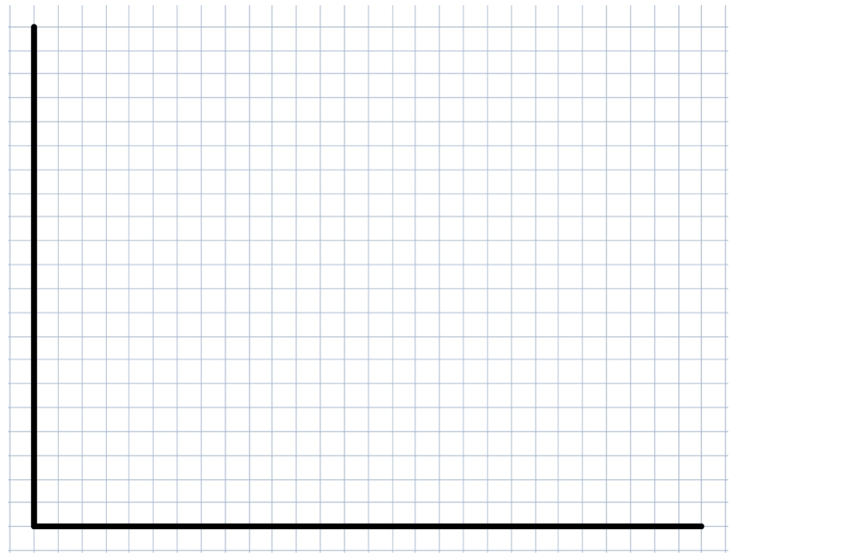Use the equations to construct a piecewise graph for $0≤x≤50$

|  |
| --- |
| 3 marks |

**Question 3 (4 marks)**

The Melbourne Museum charges $10 for children and $15 for adults.  
One hundred and twenty-five people attended the Melbourne Museum within the first two hours of opening, an amount of $1325 was collected in ticket fees.   
Write a set of equations to represent the number of tickets sold and the amount collected in ticket fees and determine how many adults, *x,* and children, *y,* attended the museum during this time period.

|  |
| --- |
|  |
|  |
|  |
|  |
|  |
|  |
|  |
|  |
|  |
|  |
|  |
|  |
|  |
|  |
|  |
|  |
|  |
| 4 marks |

**END OF TEST**